**Tables for DB Project**

**create schema db;**

**use db;**

**CREATE TABLE Customer**

**(**

**customerID INT AUTO_INCREMENT PRIMARY KEY,**

**customerName VARCHAR(100) NOT NULL,**

**customerEmail VARCHAR(100) UNIQUE NOT NULL,**

**customerAddress VARCHAR(255),**

**customerPhoneNumber VARCHAR(15)**

**);**

**CREATE TABLE Category**

**(**

**categoryID INT AUTO_INCREMENT PRIMARY KEY,**

**categoryName VARCHAR(100) NOT NULL,**

**description TEXT**

**);**

**CREATE TABLE Supplier**

**(**

**supplierID INT AUTO_INCREMENT PRIMARY KEY,**

**supplierName VARCHAR(100) NOT NULL,**

**contactEmail VARCHAR(100),**

**phone VARCHAR(15)**

**);**

**CREATE TABLE Product**

**(**

**productID INT AUTO_INCREMENT PRIMARY KEY,**

**productName VARCHAR(100) NOT NULL,**

**description TEXT,**

**price DECIMAL(10, 2) NOT NULL,**

**stockQuantity INT NOT NULL,**

**categoryID INT,**

**supplierID INT,**

**FOREIGN KEY (categoryID) REFERENCES Category(categoryID),**

**FOREIGN KEY (supplierID) REFERENCES Supplier(supplierID)**

**);**

**CREATE TABLE Orders**

**(**

**orderID INT AUTO_INCREMENT PRIMARY KEY,**

**customerID INT,**

**orderDate DATE not null,**

**orderStatus ENUM('pending', 'completed', 'cancelled') NOT NULL,**

**FOREIGN KEY (customerID) REFERENCES Customer(customerID)**

**);**

**CREATE TABLE OrderItem**

**(**

**orderItemID INT AUTO_INCREMENT PRIMARY KEY,**

**orderID INT,**

**productID INT,**

**purchaseQuantity INT NOT NULL,**

**totalPrice DECIMAL(10, 2) NOT NULL,**

**FOREIGN KEY (orderID) REFERENCES Orders(orderID),**

**FOREIGN KEY (productID) REFERENCES Product(productID)**

**);**

**CREATE TABLE Transactions**

**(**

**transactionID INT AUTO_INCREMENT PRIMARY KEY,**

**orderID INT,**

**totalAmount DECIMAL(10, 2) NOT NULL,**

**paymentMethod ENUM('credit_card', 'paypal', 'bank_transfer') NOT NULL,**

**timestamp DATETIME DEFAULT CURRENT_TIMESTAMP,**

**status ENUM('successful', 'failed') NOT NULL,**

**FOREIGN KEY (orderID) REFERENCES Orders(orderID)**

**);**

**CREATE TABLE Delivery**

**(**

**deliveryID INT AUTO_INCREMENT PRIMARY KEY,**

**orderID INT,**

**deliveryDate DATETIME,**

**status ENUM('pending', 'delivered', 'returned') NOT NULL,**

**deliveryPerson VARCHAR(100),**

**customerAddress VARCHAR(255),**

**FOREIGN KEY (orderID) REFERENCES Orders(orderID)**

**);**

**CREATE TABLE UserAuth**

**(**

**userAuthID INT AUTO_INCREMENT PRIMARY KEY,**

**customerID INT UNIQUE,**

**username VARCHAR(50) UNIQUE NOT NULL,**

**password VARCHAR(255) NOT NULL,**

**createdAt DATETIME DEFAULT CURRENT_TIMESTAMP,**

**updatedAt DATETIME DEFAULT CURRENT_TIMESTAMP ON UPDATE CURRENT_TIMESTAMP,**

**FOREIGN KEY (customerID) REFERENCES Customer(customerID)**

**);**

**ALTER TABLE Customer**

**ADD COLUMN userAuthID INT,**

**ADD FOREIGN KEY (userAuthID) REFERENCES UserAuth(userAuthID);**

**use db;**

**INSERT INTO Category (categoryName, description)**

**VALUES**

**('Electronics', 'Devices, gadgets, and accessories'),**

**('Books', 'Printed and electronic books'),**

**('Clothing', 'Apparel for men, women, and children'),**

**('Home & Kitchen', 'Home appliances, furniture, and kitchenware');**

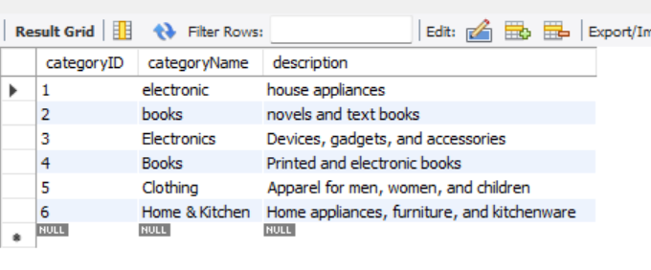

**INSERT INTO Supplier (supplierName, contactEmail, phone)**

**VALUES**

**('Best Electronics', 'contact@bestelectronics.com', '555-7890'),**

**('Books Galore', 'info@booksgalore.com', '555-2345'),**

**('Fashion World', 'sales@fashionworld.com', '555-6789'),**

**('Home Essentials', 'support@homeessentials.com', '555-4567');**

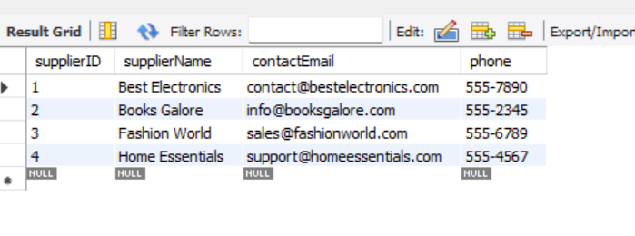

**INSERT INTO Product (productName, description, price, stockQuantity, categoryID, supplierID)**

**VALUES**

**('Smartphone', 'Latest model with 128GB storage', 699.99, 50, 1, 1),**

**('Laptop', '15-inch screen, 8GB RAM', 999.99, 30, 1, 1),**

**('Mystery Novel', 'A gripping mystery novel', 15.99, 100, 2, 2),**

**('T-shirt', 'Cotton T-shirt, available in multiple sizes', 9.99, 200, 3, 3),**

**('Blender', 'High-speed blender with multiple settings', 49.99, 40, 4, 4);**

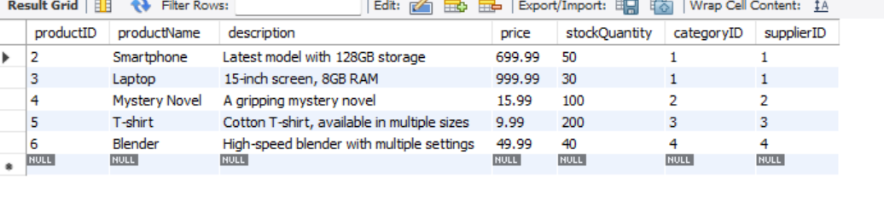

**No insert code for customer,order,order item,delivery,transaction because it is done on the point during code.**

